**Beautiful bountiful Barwon River**

Information retrieved 25th July, 2019 from Geelong Barwon river authority:

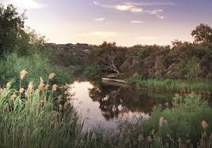 <https://www.geelongaustralia.com.au/parks/item/barwonriver.aspx>

The river and its environs are marvellous places for watersports, walking, cycling, fishing or just relaxing. There are ample facilities to help you enjoy a visit. You can picnic at riverside Queens Park, watch the water cascade over Buckley Falls or stroll or cycle the kilometres of sealed paths along the river's banks.

They pass fascinating wetlands, parks, a golf course, the Yollinko Aboriginal Garden and urban areas. Enjoy the native birds at Balyang Sanctuary or visit the Barwon Valley Park adventure playground.  
  
One of the iconic river systems in Victoria, the Barwon begins in the Otway Ranges and flows through the heart of Geelong on its 160km journey to meet the sea at Barwon Heads.  
  
The riverside vegetation is characterised by River Red Gum, Blackwood, Silver Wattle and Woolly Tea Tree, while the drier slopes are home to Drooping Sheoke Golden Wattle and the indigenous Kangaroo, Wallaby and Tussock grasses.  
  
The reserve is also rich in bird life with over 100 species found including the secretive Nankeen Night Heron. Keen eyes might also see platypus, native water rat and the occasional swamp wallaby by the water’s edge.  
  
The area has a rich Aboriginal history and was an important source of food, such as eels and fish, for the Wathaurong people.

For walking maps, see: <https://walkingmaps.com.au/walk/2422>